‘Summary Findings: Gender Responsive Budgeting and Boys’ and Girls’ Education in Timor Leste’,
Briefing paper to Ministry of Education, 29th March 2010, Dili Timor-Leste.
Rhonda Sharp, Siobhan Austen, Diane Elson and Monica Costa
Available at: www.unisa.edu.au/genderbudgets

1. The project
The Gender Responsive Budgeting project aimed to assess how government expenditure could be better targeted to meet the educational needs of boys and girls and reduce gender gaps in school attendance. It looked at the population shares of rural and urban boys and girls using the Timor-Leste Living Standards Survey (TLLSS). Information on the school attendance of boys and girls from the TLLSS was then matched with the budgetary data for the same year (2006/07) to identify the share of educational expenditure (‘the spend’) on the different groups of children*. It was found that government spending on rural girls at pre-secondary and secondary school levels was particularly low in relation to their population share.

2. Gender spending gaps
(a) There is an overall spending gap girls compared to boys (primary, pre secondary and secondary combined)
Figure1: Share of school expenditure (all levels) of boys and girls
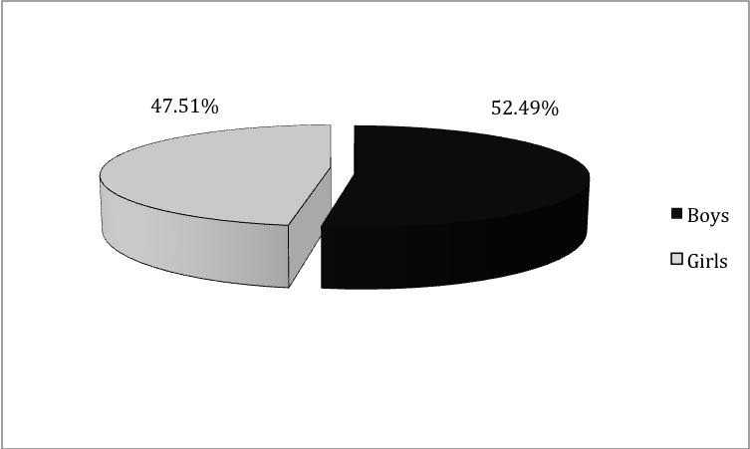
Figure 1 shows that boys share of total education expenditure was higher than that of girls. Total education expenditure on boys in 2006/07 was about $0.8 million, or 9.3 %, higher than that of girls. This result reflects the higher overall attendance rates of boys.
In figures 2-4 below the gaps in government education spending at different levels of schooling by gender and location are shown. This gender budget analysis:
- indicates a gender difference in spending on girls relative to their population shares especially beyond primary schooling
- highlights that the spending gap is mainly driven by the lack of attendance of girls
- shows that government spending on rural girls is the lowest relative to other groups.

(b) At primary school level there is small difference in education expenditure for rural girls and boys and urban boys and girls.
Figure 2: Shares in primary school expenditure, and shares in the total population of primary school age children, by sex and location
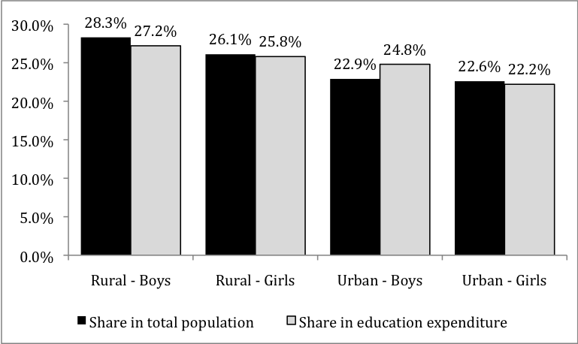

Figure 2 shows that rural girls and boys comprise a larger share of the population of primary school age children than urban girls and boys so we would expect them to get a larger share of expenditure. In fact, due to the relatively low attendance rates in rural areas, rural girls and boys share of expenditure (25.8% and 27.2% respectively) is slightly lower than their share in the population.

(c) Gender and location differences matter more at pre-secondary (or junior secondary) level.
Figure 3: Shares in pre-secondary school expenditure and shares in the total population of pre-secondary school age children, by sex and location
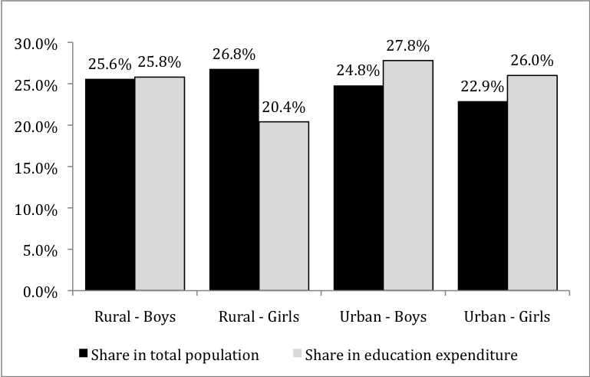

Figure 3 shows that the share of rural girls in education expenditure (20.4%) is lower by more than five percentage points than any other group and is lower than you would expect for their population share (26.8%). This highlights the low attendance rates of pre-secondary aged girls in rural areas.

(d) The disadvantage of rural girls is even more pronounced at secondary level.
Figure 4: Shares in secondary school expenditure and shares in the total population of pre-secondary school age children, by sex and location
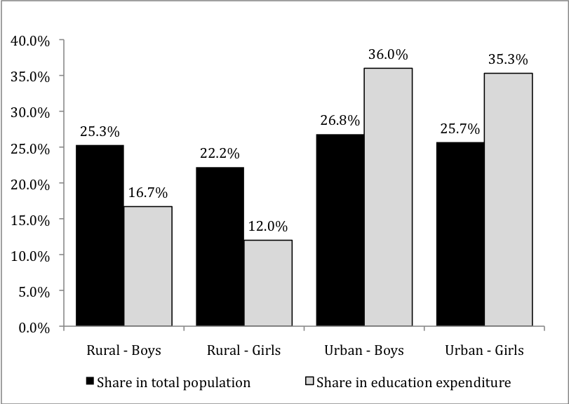
Figure 4 shows that while both boys and girls in rural areas get a relatively small share of total expenditures on secondary schooling, the expenditure share of rural girls is particularly small – at only 12% as compared to 16% for rural boys. These expenditure shares fall well short of the groups’ population share, suggesting they should get more. In contrast, urban boys get 36% of the spend on secondary education and urban girls only just below this (35.3%), but their population shares are only slightly higher than rural boys and girls.

3. What to do in order to improve gender equality in schooling?
Our study suggests targeting expenditures to those groups where attendance rates are relatively low. This involves four main steps:
- Identify the factors affecting the attendance of girls, especially rural girls.
- Prioritize activities/programs.
- Cost alternative programs designed to deal with the barriers to girls’ attendance.
- Include chosen activities/programs in the planning and budgeting system.
1) Identify the risk factors for school attendance of girls, especially rural girls
(i) Our study, using the TSLSS, analyzed 8 variables about individual and household characteristics to see which factors most affected the chances of school attendance for different aged girls:
- Their age
- Whether they live in an urban location
- Whether their household’s food consumption is above the food poverty line
- The number of adults in the household who had attended school
- The number of infants in the household
- The number of adults in the household with poor health
- Their own heath
- Whether Tetum or another language is spoken in the household.
Factors affecting the attendance of primary school aged girls.
A primary school age girl’s chance of attending school is about 55%. In this age group the household’s language background appears to be a key risk factor. However, if she is from a household where only Tetum is spoken her chance of attending primary school is about 20 percentage points higher. The apparent risks of low school attendance by primary school age girls from other language backgrounds is worthy of further investigation and, possibly intervention.
Other significant factors affecting the chances of a primary school aged girl attending school include her age and rural location. Each additional year of age raises the chance of attendance by 17 percentage points. Rural girls have lower chances of attending school than their urban counterparts. This highlights current problems with the attendance of young girls, especially in rural areas.
Factors affecting the attendance of pre-secondary school aged girls.
In this age group poverty is a key risk factor affecting school attendance. Girls living in a household where food consumption is below the food poverty line- has a chance of attending school that is 14 percentage points lower than girls in other households.
The number of adults in the household who had attended school also strongly affects the chances that a pre-secondary age girl will attend school.
Factors affecting the attending of secondary school aged girls.
In this age group the chances of attending school falls rapidly with age. This has implications for the late age of starting school by rural girls and achieving nine years of basic education.
Rural girls have a much lower chance of attending secondary school than urban girls.
Girls living in households where there are few adults with a school background, or in households with sick adults, are also at risk of non attendance.
2) Prioritize activities/programs to solve to improve attendance of rural girls
International studies:
International studies have examined the factors affecting girls attendance at school using data on factors not measured in the TLLSS, such as school quality. The international research indicates the following programs are important for improving the school attendance of girls:
- Having separate and adequate toilets for girls
- Proving scholarships
- Increasing the number of female teachers
- Improving the income and education levels of mothers.
What is Timor Leste already funding?
Programs that target removal of barriers to the attendance of girls at school include:
- improvement of school facilities
- removal of school fees
- school meals
- educational subsidies for children paid to mothers.
- scholarships
3) Cost alternative programs designed to deal with the barriers to girls’ attendance
For programs already in place the following questions could be asked:
- Are these adequately funded and appropriately designed?
- Has the money been spent as planned?
- Has funding been reduced and increased in more recent budgets? Why?
Cost new programs or initiatives that might be proposed.
Identify funding sources including new monies, re-allocate of existing resources to new programs, country partnerships.
The list of priorities in 2) above will probably change in the light of the costings and the available funds. Also what is politically possible is another consideration.
4) Include chosen activities/programs in planning and budgeting processes
- What are the relevant processes?- Annual Action Plans, Strategic Plan etc
- Across all stages of planning and budgetary decision making- formulation, implementation, monitoring and evaluation
- What political support is needed?

Summary of steps in gender responsive budgeting and planning
- Identify of problem - low attendance rates which can impact on achieving the law of nine years of basic education.
- Do an analysis of the nature of the problem using sex disaggregated data - girls and boys attendance- educational spend is lower for rural girls at pre-secondary and secondary levels of schooling and for rural boys at secondary schooling.
- Identify the factors contributing to the problem - key risk factors in girls attendance at the different levels of schooling.
- Identify possible activities/programs that would reduce the problem.
- Prioritize activities/programs.
- Cost alternative programs designed to deal with the barriers to girls’ attendance.
- Include chosen activities/programs in the planning and budgeting systems.

