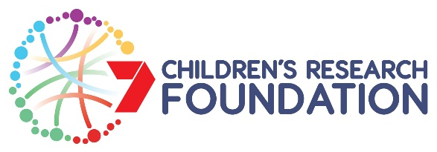

Healthy Development Adelaide and Channel 7 Children’s Research Foundation PhD Excellence Award 2019

HDA Application

Closing date: 5.00pm Tuesday 8 January 2019

Submission Date:
Applicant
Surname: |  |  | First Name:
PhD Student | PhD commencement (dd/mm/yyyy):
 | Full name of scholarship awarded:
University and Department/s
Telephone: |  |  | Email:
Primary/ principal supervisor: |  |  | Telephone & email:
Co-supervisors |  |  | Institution & contact email
PhD Project Title
Provide a title here

PhD Project & relevance to HDA
Provide a brief description ‘in lay terms’ of your research project, and indicate how it aligns with the theme of Healthy Development. Provide also a brief statement of how your research project and/or supervisory team meet the multidisciplinary criterion required for this scholarship. (250-350 words)

Name of Applicant |  | Signature of Applicant |  |  | Date
Name of Primary HDA Supervisor |  | Signature of Primary Supervisor |  |  | Date

