Are you living in a retirement village in South Australia?
Participants are needed for a UniSA study exploring the impact of pet policies on the health of residents in retirement villages.
You will be asked to complete a short questionnaire reporting your physical activity, social health, and mental wellbeing.
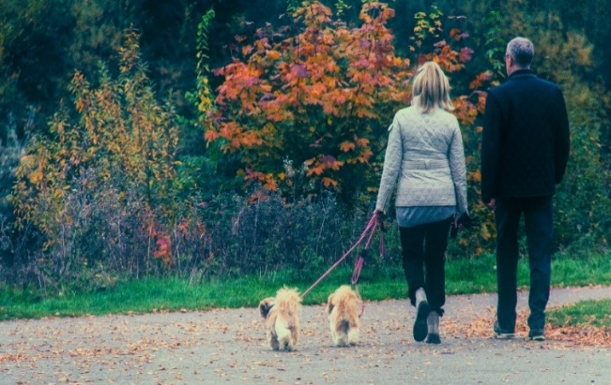

Photo by Mark Timberlake on Unsplash

The online survey can be accessed at https://redcap.link/petsandhealth or by scanning the QR code below.

If you prefer a hard-copy survey, or for more information,
Phone: 8302 1365
Email: unisa.researchvolunteers@unisa.edu.au

